**뷰의 삭제**

1. **Drop view sample_view_67;**
2. **Drop view sample_view_672;**
3. **Select * from sample_view_67;**
4. **Select * from sample_view_672;**

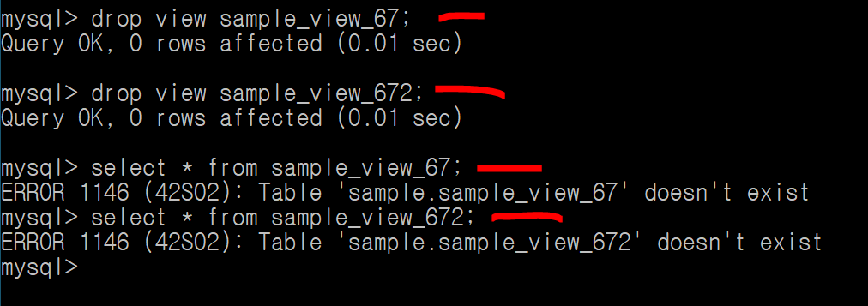

**뷰를 삭제할 수 있다**